**Dead cell**

The diagram shows a plant cell.

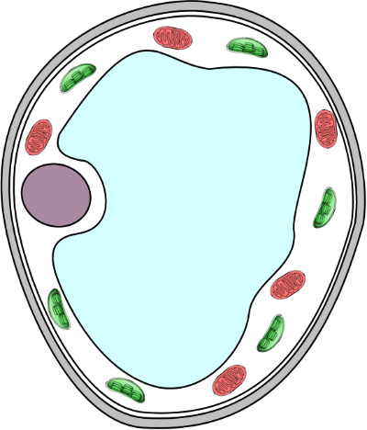

cytoplasm

cell wall

cell membrane

Imagine that you killed the cell with poison.

1. What would happen to diffusion in the cell cytoplasm and through the cell membrane?

|  |  |
| --- | --- |
| **A** | Diffusion would stop immediately. |
| **B** | Diffusion would continue for a short time and then stop. |
| **C** | Diffusion would continue. |

1. How would you explain your answer to question 1?

|  |  |
| --- | --- |
| **A** | Diffusion requires energy from the cell. |
| **B** | Diffusion happens because molecules move all the time. |
| **C** | Diffusion only takes place in living systems. |
| **D** | All life processes in the cell have stopped. |

*Biology > Big idea BCL: The cellular basis of life > Topic BCL1: Cells > Key concept BCL1.4: Diffusion and the cell membrane*

|  |
| --- |
| **Diagnostic question** |
| **Dead cell** |

**Overview**

|  |  |
| --- | --- |
| Learning focus: | Molecules move through the cell cytoplasm by diffusion, and some molecules can enter and leave a cell by diffusing through the cell membrane. |
| Observable learning outcome: | Explain the diffusion of particles through a selectively permeable membrane. |
| Question type: | Two-tier multiple choice |
| Key words: | membrane, diffusion, living |

**What does the research say?**

Odom (1995) has defined a list of knowledge statements required for understanding diffusion in the context of cells, including:

* All particles are in constant motion.
* Diffusion involves the movement of particles.
* Diffusion results from the random motion and/or collisions of particles (ions or molecules).
* Diffusion occurs in living and non-living systems.

Various researchers (e.g. Odom, 1995; Tomažič and Vidic, 2012; Oztas and Oztas, 2016) have described the use of two-tier multiple choice questions to diagnose students’ misconceptions related to diffusion in the context of cells, including a series of questions known as the ‘Diffusion and Osmosis Diagnostic Test’ (DODT), as described by Odom and Barrow (1995).

These tests have revealed common misunderstandings about diffusion amongst students, including that diffusion across a cell membrane requires energy from a cell (or in some other way depends on the presence of a *living* cell), and would stop if the cell died.

**Ways to use this question**

Students should complete the questions individually. This could be a pencil and paper exercise, or you could use the PowerPoint presentation with an electronic voting system or mini white boards.

The answers will show you whether students understand that diffusion of molecules across a membrane takes place in both living and non-living systems, and does not depend on anything provided by a living cell.

*Differentiation*

You may choose to read the questions to the class, so that everyone can focus on the science. In some situations it may be more appropriate for a teaching assistant to read for one or two students.

**Expected answers**

1. C - Diffusion would continue.
2. B - Diffusion happens because molecules move all the time.

**How to respond - what next?**

If there is a range of answers, you may choose to respond through structured class discussion. Ask one student to explain why they gave the answer they did; ask another student to explain why they agree with them; ask another to explain why they disagree, and so on. This sort of discussion gives students the opportunity to explore their thinking and for you to really understand their learning needs. Responses often work best when the activities involve paired or small group discussions, which encourage social construction of new ideas through dialogue.

Researchers have described constructivist approaches that enable students to build their own explanations of diffusion, which may help to develop students’ understanding and overcome misconceptions, including use group discussion and challenging students to apply concepts they have been taught to make predictions (Christianson and Fisher, 1999). The following BEST ‘response activity’ facilitates these types of activities and reinforce the idea that diffusion does take place across non-living membranes and does not depend on anything provided by a living cell. It could therefore be used in follow-up to this diagnostic question:

* Response activity: PEOE – A cup of tea

**Acknowledgments**

Developed by Alistair Moore (UYSEG), adapted from Q11 in the ‘Diffusion and Osmosis Diagnostic Test’ (DODT) as described by Odom and Barrow (1995).

Images: mitochondria – Wikimedia Commons/Nevit (adapted by UYSEG); chloroplasts – pixabay.com/Clker-Free-Vector-Images (35023) (adapted by UYSEG); all other drawings – UYSEG

**References**

Christianson, R. G. and Fisher, K. M. (1999). Comparison of student learning about diffusion and osmosis in constructivist and traditional classrooms. *International Journal of Science Education,* 21(6)**,** 687-698.

Odom, A. (1995). Secondary & college biology students' misconceptions about diffusion & osmosis. *The American Biology Teacher,* 57(7)**,** 409-415.

Odom, A. L. and Barrow, L. H. (1995). Development and application of a two-tier diagnostic test measuring college biology students' understanding of diffusion and osmosis after a course of instruction. *Journal of Research in Science Teaching,* 32(1)**,** 45-61.

Oztas, F. and Oztas, H. (2016). How do biology teacher candidates know particulate movements & random nature of matter and their effects to diffusion. *Journal of Education and Practice,* 7(29)**,** 189-194.

Tomažič, I. and Vidic, T. (2012). Future science teachers' understandings of diffusion and osmosis concepts. *Journal of Biological Education,* 46**,** 66-71.